# A black rectangular device with a microphone Description automatically generatedSennheiser TeamConnect Bars Now Available in Barco Try and Buy Program

**Organizations across Europe can experience the TeamConnect Bars with Barco ClickShare Conference through a new trial offer**

**Wedemark, Germany — October 15, 2024 —** [**Sennheiser**](http://www.sennheiser.com/)**, the first choice for advanced audio technology that makes collaboration and learning easier, today announced its TeamConnect (TC) Bar Solutions will be added to the Barco Try and Buy program for end user customers in Europe. As part of the program, customers can loan a Barco ClickShare solution with a TC Bar S or TC Bar M free of charge for a 30-day period. Participants in the program will be connected to a certified reseller, who will provide support throughout the trial process.**

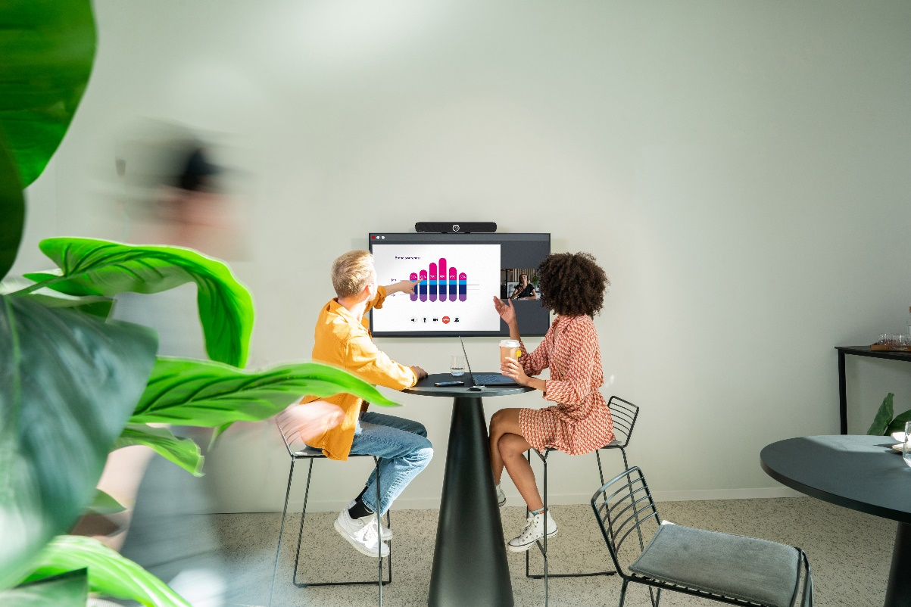

Sennheiser’s TeamConnect (TC) Bar Solutions will be added to the Barco Try and Buy program for end user customers in Europe

Sennheiser’s TC Bar Solutions (TC Bar S and TC Bar M) integrate effortlessly with Barco ClickShare Conference for a consistent, intuitive experience. Best-in-class audio ensures clear conversations, and patented beamforming technology delivers smooth presenter transitions. The Dante port allows mic extension and flexible space configuration, while 4K AI-enhanced video optimizes every detail for remote participants. Multiple mounting options simplify integration into any space, while certified integration with Barco ClickShare ensures a smooth setup process.

ClickShare enables instant meeting starts and easy content sharing, leveraging the TC Bar to create a user-friendly environment, where technology discreetly enhances the flow of discussion. ClickShare Conference simplifies wireless collaboration, and when paired with Sennheiser's all-in-one video bars, it creates organized and clutter-free environments, leading to impactful meeting experiences.

Sennheiser’s TC Bar Solutions (TC Bar S and TC Bar M) integrate effortlessly with Barco ClickShare Conference for a consistent, intuitive experience

“We’ve had a meaningful partnership with Barco for many years now, with a shared vision of creating intuitive meeting environments to enhance opportunities for success,” said Charlie Jones, Global Partner Relations Manager for Sennheiser. “The addition of our TC Bar Solutions to the Barco Try and Buy program is yet another way we are working together provide technology that allows everyone to hear clearly, see fully, and interact freely in meeting environments.”

ClickShare Conference simplifies wireless collaboration, and when paired with Sennheiser's all-in-one video bars, it creates organized and clutter-free environments, leading to impactful meeting experiences

“Our long-standing partnership with Sennheiser is built on a common commitment to creating exceptional user experiences in the hybrid workplace,” said Dan Root, Head of Global Strategic Alliances at Barco ClickShare. “Bringing joint solutions in our Try & Buy Program is the next step in deepening our partnership. Together we set a new standard for customers looking for engaged video collaboration in any type of meeting space.”

To participate in the Barco Try and Buy program, customers can complete a request form via Barco’s Website: [TC Bar S & CX-30 Try & Buy](https://eur03.safelinks.protection.outlook.com/?url=https%3A%2F%2Fbarco.com%2Fen%2Fproduct%2Fsennheiser-tc-bar-s-clickshare-cx-30-bundle&data=05%7C02%7CErica.Whittle%40sennheiser.com%7C42a098c045924a045df808dce77b3d68%7C1c939853ca0f479295978519b4d0dfe3%7C0%7C0%7C638639763754168137%7CUnknown%7CTWFpbGZsb3d8eyJWIjoiMC4wLjAwMDAiLCJQIjoiV2luMzIiLCJBTiI6Ik1haWwiLCJXVCI6Mn0%3D%7C0%7C%7C%7C&sdata=rusjZDjtPOl%2Bt1T6ApKzKrjk2tdLoqIs%2BpgeEhLL0pg%3D&reserved=0),  [TC Bar M & ClickShare CX-30 Try & Buy](https://eur03.safelinks.protection.outlook.com/?url=https%3A%2F%2Fbarco.com%2Fen%2Fproduct%2Fsennheiser-tc-bar-m-clickshare-cx-30-bundle&data=05%7C02%7CErica.Whittle%40sennheiser.com%7C42a098c045924a045df808dce77b3d68%7C1c939853ca0f479295978519b4d0dfe3%7C0%7C0%7C638639763754192185%7CUnknown%7CTWFpbGZsb3d8eyJWIjoiMC4wLjAwMDAiLCJQIjoiV2luMzIiLCJBTiI6Ik1haWwiLCJXVCI6Mn0%3D%7C0%7C%7C%7C&sdata=hS6bmyKGYYFFufu0Wj7nCM9zAq332g93iP8INLciwrs%3D&reserved=0). For more information about the Sennheiser and Barco partnership, visit <https://www.sennheiser.com/en-us/global-cooperation/barco>.

###

**About the Sennheiser brand**

We live and breathe audio. We are driven by the passion to create audio solutions that make a difference. Building the future of audio and bringing remarkable sound experiences to our customers – this is what the Sennheiser brand has represented for more than 75 years. While professional audio solutions such as microphones, meeting solutions, streaming technologies and monitoring systems are part of the business of Sennheiser electronic SE & Co. KG, the business with consumer devices such as headphones, soundbars and speech-enhanced hearables is operated by Sonova Holding AG under the license of Sennheiser.

[www.sennheiser.com](http://www.sennheiser.com)

[www.sennheiser-hearing.com](http://www.sennheiser-hearing.com)

|  |  |
| --- | --- |
| **Local Press Contacts**  Kirsten Spruch  [kirsten.spruch@sennheiser.com](mailto:kirsten.spruch@sennheiser.com) +1 (860) 598-7484 | **Global Press Contact**  Jeff Horan  [jeffrey.horan@sennheiser.com](mailto:jeffrey.horan@sennheiser.com)  +1 860-598-7539 |
| InGear  Peter Schuyler  [peter@ingearpr.com](mailto:peter@ingearpr.com)  +1 917-496-8970 |  |